Company website, Drink brand?

Summer vibe

Use of no block style/colour on navbar, same colour as background/image

Large Parallax slider with text or nav overlay

Large Text and clean minimalistic colours

Light fresh colour pellet

<https://www.engineeredfloors.com/>

Full page overlay for mobile, bottom up animation

Transparency decrease on alternating nav options on hover rather than the one hovered

#FFF color for background

[https://moon-project.webflow.io/#](https://moon-project.webflow.io/)

Page overlays as transitions between webpages,

<https://www.hm.la/>

logo on nav text animation on hover effect, logo staying and business name appears

<https://tenson.com/en-se/start>

Image zooms on links that have photos, offers a jumping out effect

Double footer with 2 color sections, privacy statement and page links

<https://matterapp.com/home>

50% page width scroll only, 1 side stays stationary

Could be useful for gallery with title

<https://www.w3docs.com/snippets/css/how-to-create-two-inline-block-columns-with-50-width.html>

 Fonts for logo <https://www.jukeboxprint.com/blog/23-of-the-best-fonts-for-designers-2023>

<https://alvarotrigo.com/blog/hamburger-menu-css/>

<https://blog.zibster.com/text-image-layouts>

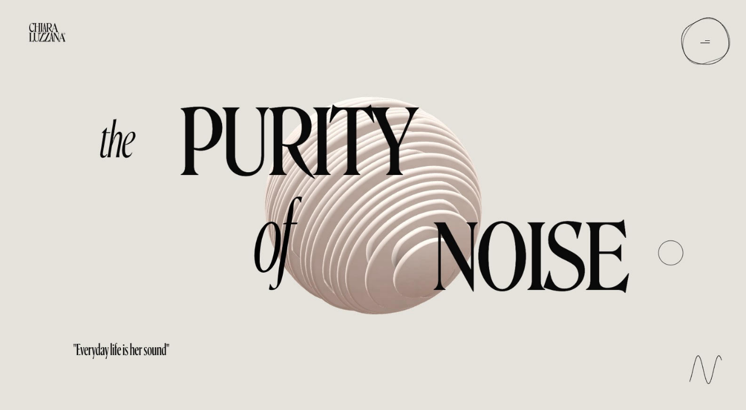

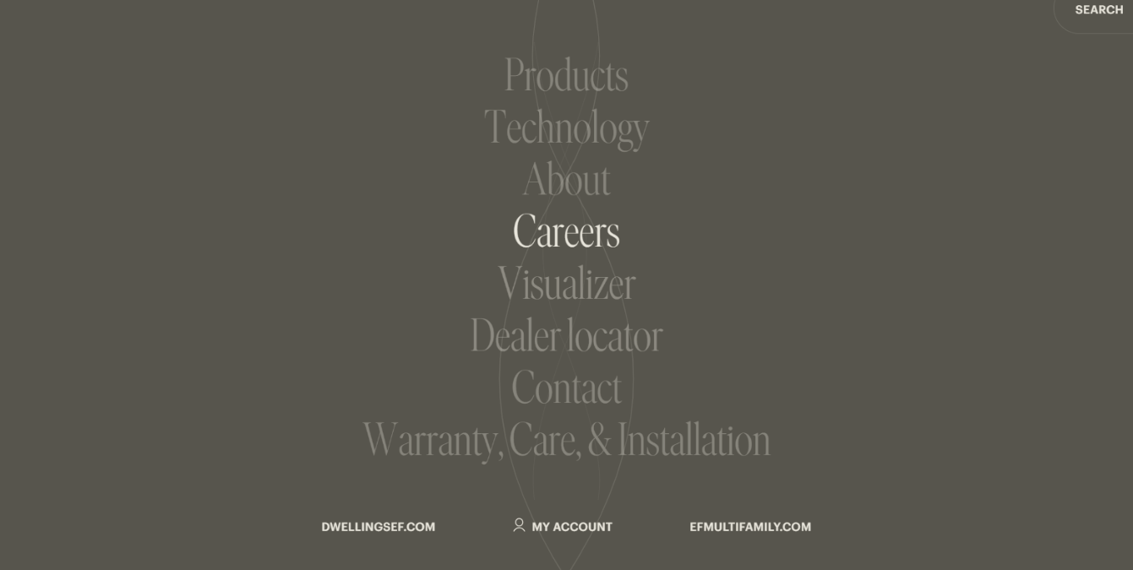



This is a document I used from the start to collect ideas for my website, the 3 sites I will write about are:

<https://matterapp.com/>

<https://tenson.com/en-se/start>

<https://www.engineeredfloors.com/>

I chose these sites based off elements I like from each of them, from the matter website I liked the minimalist design and the scrolling effects, the colour pallet of white with pops of colour works well. From the tenson site I like the way the have arranged the photos without the site feeling crowded or chaotic, the use of zoom hover effects was something I though was impressive. The engineered floors website is very impressive I like the choice of colour pallet with the off white background paired with the earthy neutral colours the scrolling effects as well are obviously impressive.

Things about these 3 sites I could critique are how narrow the matter website is and maybe too much whitespace, some improvements for the tenson website would be being able to click out of the nav bar drop down once clicking it, also the use of white text hover on the footer could have been done better, I don’t like the choice of font on the engineered floors website and the spacing on the footer could have been improved.

Elements I have incorporated or have used as inspiration for own site would be the image scrolling effect on the matter webpage, this was something a saw early in the project and wanted to ensure I used it, I have it on my first wireframe.

This is the matter site

This is my site

On the tenson site they used a nice hover effect which made the image in large, I used this on my gallery page for my website.

My website

The engineered floors site gave me inspiration when choosing a colour pallet, they have used an off white background which made me choose a colour slightly off white.

engineered floors site

My website

